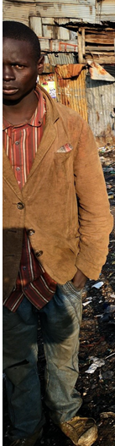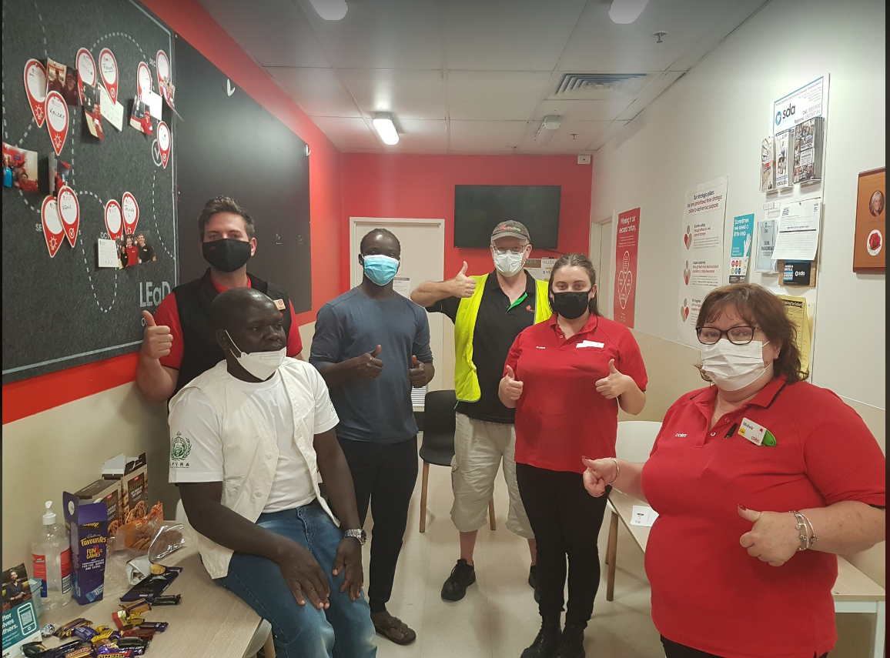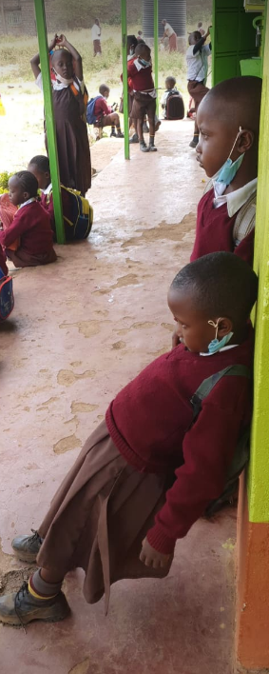
“PROJECT”
Wellbeing minds for Wellbeing lives

Contact Information
76 Beaudesert, Road Moorooka, Peter Lino: Executive Director
Qld, 4107. admin@ufvra.org.au
www.ufvra.org.au 0721030518

A PROPOSAL FOR THE SUCCESS OF Wellbeing Minds For Wellbeing Live (Homeless Youths Project) (2021-2023).
Issues
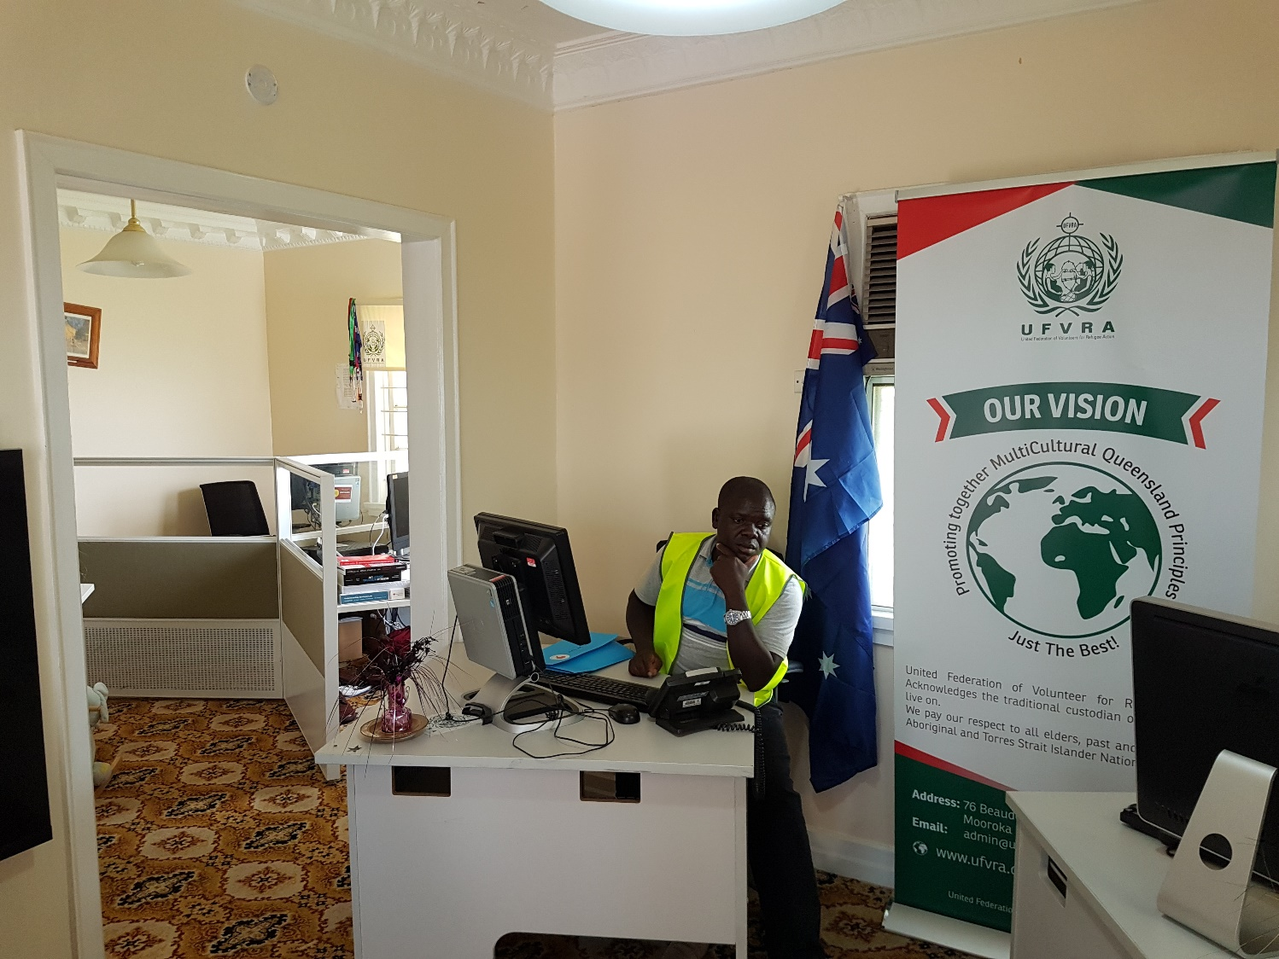
Brisbane Youth homelessness is on the rise, both in Brisbane and state-wide. In the 2017‐2017 school year, 213 youth enrolled in the Milperra State High Schools were homeless. "Homeless" is defined as means not having a home, and you don't have to be living on the street to be lost, any student who lacks a regular, fixed, night-time residence. These include couch surfing, living in weekly rate motels, doubled‐up, shelters, and parks, camping, on the streets, or living in substandard blight conditions. A variety of factors contribute to the unstable housing situations of these children. Schools and service providers around the region are seeing more first‐time homelessness in youth and families.
Street youth frequently face a vicious cycle of challenges. They feel discouraged and hopeless, violent, life threats, threats of harm, disappearance, lack of shelter, food, health care. And sometimes, self-medicating with drugs, family domestic violence, or alcohol leads to unfavorable interactions with law enforcement, which causes difficulty for them in school success, finding housing, and employment, thus leading to further lack of confidence self-worth. Sleeping and staying on the streets creates a host of additional problems for teens in this area. Including a higher risk of sexual abuse and sexually transmitted diseases, like (AIDS), mental health issues, decreased access to health care, and unhealthy relationships that lead to routine sexual acts among themselves, without knowing who carries diseases. Example Aids is too much within African Communities that we currently as volunteers feared and need to raise awareness to prevent.
Proposed Solutions
Wellbeing minds for Wellbeing live Project, a nationally‐recognized goal‐oriented resource center, provides an integrated place for homeless youth to connect with a multitude of resources and services while receiving wrap‐around case management to ensure a continuum of care and referral.

WMFWL proposes the addition of a resource center located at Milperra State High Schools that built upon Wellbeing minds for Wellbeing lives. The Project's existing successful model improves the identification, tracking, and reporting of homeless youth in Brisbane. Expedite access to services and basic needs, further develop programs and opportunities, and strengthen youth and families' services. Additional leverage support and provide wrap‐around case management, in particular to African Australian children. We are out of control resulting in many reasons considered (Milperra State Schools in Brisbane crass almost all Refugees and migrants) that produced poor students, 88 % within crimes. And 12% are good citizens that we intervene to prevent antisocial character through case management.

Upon referral from school volunteers, teachers, principals, school staff, agencies, parents, or other community members, the case manager will contact the youth (if an older teen or unaccompanied) or parent(s). Through this conversation, as well as input from the referral source, the case manager then makes an inclusive individual assessment of the youth's situation and needs and creates a case management plan accordingly.

This assessment includes the following information:

Educational and enrolment status
- Current living situation-night‐time residency
- Barriers to education, including transportation and shelter, transfer requests, etc.
- Basic needs, like clothing, school supplies, hygiene supplies, food, etc.
- Physical health, mental health, and drug-alcohol treatment needs
- Domestic violence issues in the household
- Parent background and school attendance
- Checked on the group they associated.
The image below reflect: COVID-19 JOBLESS corners
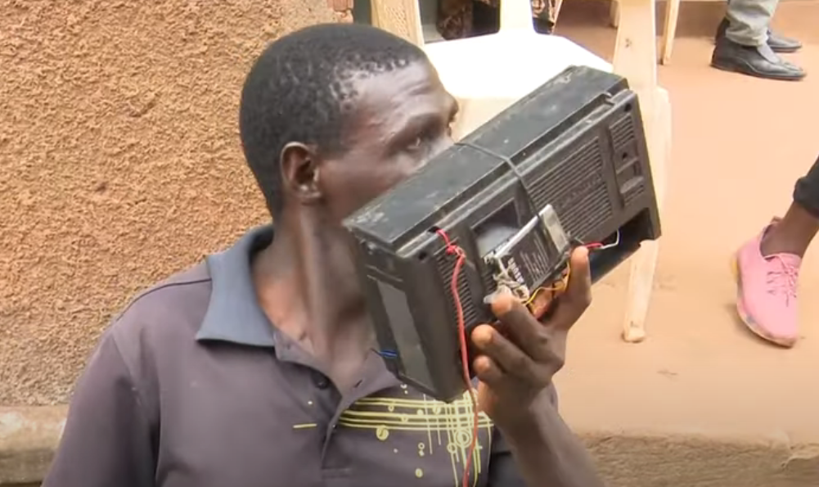
- Need for budgeting-consumer education
- Legal and or child welfare involvement or history
- Positive role models-support systems and quality of peer interaction
Of any language barriers present
WMFWL Project’s efforts to provide an integrated place for all youth to connect with many resources and services while receiving case management to ensure a range of care recognized as the Best Exercise with the wrap‐around “support” model. WMFWL Project would coordinate with our volunteers, Community Works Street Outreach night and day mobile program to target youth both in school and on the streets, re‐engage youth into school programs, or provide an alternative. In particular, African Australia confined in one house spend all hours on play stations, drugs, or some time crime committed.
Organisation Background
WMFWL Project was founded in 2019 to respond to homeless youth's growing critical needs in greater Brisbane region. WMFWL Project received not‐for‐profit status in 2015, with a mission to welcome refugees and migrants and help children build strong practicalities for Brisbane and other states' personal and educational success. We accomplish this mission by fostering self‐sufficiency, removing barriers to services and education, and providing centralized access to resources, including referral to our partners (AAWA, Foodbank, second Bite, uniting church, Queensland department) health, and other community organization. WMFWL Project delivers services to disadvantage people, youth, and families in three fields: through a drop‐in resource center, street outreach, and a school‐based inclusive program.
Project Evolved
Political Rights (ICCPR), the International Covenant on Economic, Social and Cultural Rights (ICESCR), and the Convention on the Rights of the Child (CRC). Under legal and moral obligations to promote, protect, and realize all people's human rights, including Australia's health, 2020 presents an overview of well-being in Australia. This requires all districts to ensure homeless youth have barrier‐free school enrolment, school transportation, and access to their school of origin regardless of current residence. As the Director of the organization appointed in 2017, Peter from UFVRA & Flora from AAWA Founded (WMFWL) Project, leveraging federal education resources to expand funding and services for this vulnerable population's growing needs. Now serving as the Executive Director of WMFWL Project, Peter and Flora continues to be the organization volunteers Liaison and has expanded WMFWL Project services to provide a wrap‐around integrated support model for homeless youth, including basic needs, case management, positive youth development, and support services, including taking homeless youth for outing and camping.

WMFWL Project leads Moorooka Homeless Link, in partnership with AAWA, Second Bite, and foodbank, to establish resources and services for homeless youth and families throughout the country. We work with a range of food suppliers to rescue surplus fresh food from across the network and redistribute it to local clients and communities around Brisbane to support people in need.
Integrated Service
The integrated service model earned WMFWL Project national recognition in 2008. Australian Charities and Not-for-profits Commission (ACNC) endorsed WMFWL Organisation Project as the outstanding refugee’s volunteer’s organisation and School‐Based Educational Program Providing Services to Students in Homeless Situations. Project also works with Coos Bay SD to develop their WMFWL, project and has consulted with many other communities both locally and state wide.
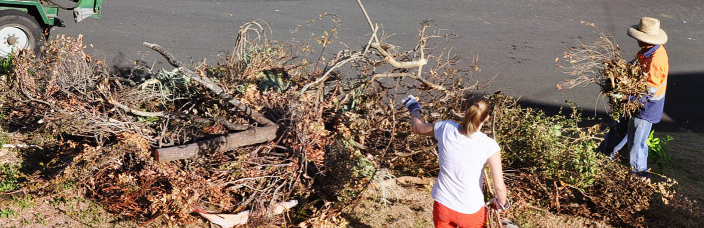

Costs and Funding Sources
Activity | Cost | Source
1 WMFWL Case Manager ($32hr, 40hrs/wk) | 39,800 | Local Foundation grants such as Australia Community Foundation, Government grant, or other foundations supporting, youths, domestic, homeless, children and education grants. Any grant or donations is welcome c/o Australia Community Foundation portal
1 WMFWL Case Manager (benefits and payroll tax, 11%) | 4,432
Supervision (11%‐Admin and oversight). | 3,899
Professional Development ( such as conferences, training, mileage) | 1,500
Program Supplies & Materials | 5,000
Client Assistance  (emergency and basic needs, fees and supplies for youth and families) | 20,000 | Part of Australia community Foundation grant seeking, to be secured as part of WMFWL Project.
1,WMFWL Community engagement officer ($27hr, 40hrs/wk) | 36,400 | Part of Australia community Foundation grant seeking, to be secured as part of WMFWL Project.
1 WMFWL Volunteers logistics cost, ( Fuel ) ( 39 volunteers) | 5000 | In-kind donation, half of the money Secured.
Total | 43,941

Volunteer staff / Administration
- Centre manager (full time). The critical role will be to ensure the centre’s smooth running, oversee the recruitment of the Homeless, and provide that the program implemented as planned.
- Social workers: Their key responsibility will be recruiting the street youths into the centre and consequent home visits to families and guardians.
- They will establish communication with these parents and guardians develop a relationship between the homeless in preparation for eventual reintegration.
- Houseparents: (full time) they are in charge of the night shelters. Their key responsibility is supervising the homeless working hours, after 5 pm. Over the weekend, i.e., they manage cooking, cleaning, homework and ensure that the homeless children adhere to all the laid down rules and procedures. THEY ALSO PARTICIPATE IN OUTDOOR ACTIVITIES

In addition to the staff as mentioned above, other personnel will be involved in the program's overall running.
WMFWL operates centralized finance, Human Resources, and procurement functions. These functions are all essential components in the project
The Human Resource function will handle volunteers, staff recruitment, training, and development remuneration and welfare while the finance governs all the financial issues.
Project Monitories and Evaluation:
At the end of each calendar year, an evaluation will be carried out to measure access to the programs' success against the set target and goals. The assessment will involve open discussion with beneficiaries, the client community, and the companies that offer partnership attachment to the homeless youths and numerous physical visits to the exited homeless schools and homes.
The data collected will be analyzed, and a report will be prepared and shred with the donors and our stakeholders inclusively. The project implementers will utilize this evaluation report to improve on project execution in the years that follow.
Project Sustainability:
Unlike other WMFWL run programs, this program cannot employ the cost sharing initiative hence relies entirely on member's contributions and Donor funds.
The Government has not supported the program in any significant way in the past. And hence not much government involvement is expected in the future.
The WMFWL management needs to continually establish new partnerships and encourage sponsorship from both local and international donors.WMFWL IS ALSO LOOKING INTO ESTABLISHING A Lumni. This will encourage past beneficiaries to support the program.
www.ufvra.org.au : ABN: 70 678 268 916
admin@ufvra.org.au|United federation of volunteers for refugee’s action |UFVRA|

